**Unity Based QR Enabled Online Book Creator**

**(Kids Learning)**

**SYNOPSIS**

**Submitted By**

## **Vaibhav Tiwari**

## **2200290140173**

**Vandana Tiwari 2200290140174**

## **Submitted in partial fulfilment of the Requirements for the Degree of**

MASTER OF COMPUTER APPLICATION

## **Under the Supervision**

## **Dr. Ankit Verma**

## **(Associate Professor)**



**Submitted to**

**DEPARTMENT OF COMPUTER APPLICATIONS**

## **KIET Group of Institutions, Ghaziabad**

## **Uttar Pradesh-201206**

**Unity Based QR Enabled Online Book Creator**

**(Kids Learning)**

**INTRODUCTION**

Augmented Reality is an advancement that incorporates a real object into a practical environment interactively. The impact of augmented reality on a student is used to explain motivation in a learning context. Augmented Reality applications as digital experiments for education modules using QR code scanner. This study aims to redesign a lesson unit supported with QR Codes and an augmented reality experience is created using the camera of a device like an iPhone or Android phone to view a real-world environment. An augmented reality experience is created using the device like mobile iPad, tablets etc. To learn the topic with real effect and the gets information for students digitally projected with the help of a camera. Database created in Vuforia developer portal then add each word QR code image, QR code image should be five-star clarity that means Scanner can find QR code at some distance. Augmented Reality applications can easily convey to students like image, video, or 3D Modules this technology helps the students to understand the complex topics and motivate them to learn more about them with digital experiments and visualization. The few recent additions to the material pools are smartphone apps using augmented reality with which the students can experiment on their own. Nowadays students are not studying a book so creating interest to study with the help of Quick Response (QR) codes for a particular word for which the student has not understood, the search is initiated with QR generator tool by QR code scanner reader application. Providing a solution for students with the help of QR code and Augmented reality. Understanding more concepts becomes easier using this application for children. The application helps the student to gain information related to the topics that can be conveyed interestingly and interactively. The project is to enable the student to be supported with additional resources to explain the topic by scanning QR code. The user can get information about photosynthesis, herbivores, carnivores, molecules, matter, etc.

**Abstract:**

This paper presents an augmented reality application for the working of a difficult word like environment, photosynthesis, molecules, matters etc. Quick Response (QR) codes is a 2D barcode that can store information such as animated or video appear everywhere these days. Technological advances brought applications of innovations to education with new technologies accompanied by more learner active environments using QR Codes by using the Internet. There are learners preferring self-learning. Traditional learning materials have been upgraded to be more appealing, motivational, and technologically advanced. The main aim to develop this AR application for understanding particular word to make learning more interesting and easier for students.

**LITERATURE REVIEW**

In [1] This study was aimed at developing an original application for education consists of AR technologies and thus usage in education. And it was revealed it is effectively used by developing a 3D interactive mobile-based AR teaching system to help the students to improve critical and complex topics more easily

In [2] This writing audit centres around increased real factors (AR) for discovering that use portable, setting mindful advances (e.g., cell phones, tablets), which empower members to associate with computerized data inserted inside the actual climate. We sum up research discoveries about AR informal and casual learning conditions in schools and colleges with an accentuation on the affordances and impediments related to AR as it identifies with educating, learning, and informative plan.

In [3] In this paper, we present an AR application to help the instructing of the environment-related and frameworks created cooperatively with a few instructors, with the reason for improving the understanding of the environment-related and circulatory cycles, developing a perspective in students and improving the learning measures.

In [4] The interaction brought about a consolidation of augmented reality frameworks and the Controller in which the framework creates animated developments and virtual 3D item use marker which estimated 21cmx29, 7cm where the outcomes utilizing best distance while camera distinguishes the marker is 20cm45cm, the camera can recognize the item utilize the slope distance between 350 degree-1450 degree.

In [5] The Augmented Reality (AR) innovation improves the human view of the world by consolidating the genuine climate with the virtual space. With the dangerous development of amazing, more affordable cell phones, and the rise of complex correspondence framework, Mobile Augmented Reality (MAR) applications are acquiring expanded fame. Blemish permits clients to run AR applications on cell phones with more prominent versatility and at a lower cost.

In [6] In this research, the author proposed to assemble the item to be used, the author used blender programming for the object modelling process. To have the option to show 3D items, authors apply target picture strategies, to be specific by utilizing a marker acquired from the book Sobotta Human Atlas Anatomy is adjusted to necessities of preclinical medical students. At the point when the AR camera catches the marker, the camera recognizes the example contained in the marker and then matches the data stored in the database.

In [7] In this survey, the author presents an increased reality learning framework that uses the input of a depth camera to intelligently instruct life systems to secondary school students. The goal is to exemplify topic explanation by showing 3D models over the body of an individual continuously, utilizing the Microsoft Kinect profundity camera.

In [8] The author aims to develop an augmented reality application such that students can easily understand the particular topic explanations using 3D image visualization. The method used in this system is AR marker on a mobile platform. The strategy utilized in this framework is an expanded reality marker on the versatile processing stage. The marker is caught by snapping a photo. At that point, the caught picture is partitioned into pieces and the example is coordinated with pictures put away in the data set.

In [9] Augmented reality can be described as a technology that allows the computer-generated virtual image to overlay a live direct or indirect real-world environment in real-time. Augmented reality has been developed and used on a big scale in a variety of applications in recent years. The usage of Augmented Reality in Education is one of them.

In [10] Augmented Reality is a new and exciting innovation in mobile technology that allows for the insertion of external data on top of camera input and output in a 3D user-friendly manner. AR is used in many areas such as the gaming world, navigation system, tourism, and education tool etc. The main objective of our project is to present the next generation of school students with a multipurpose educational tool that can be used ubiquitously in an educational environment.

In [11] Augmented Reality (AR) is touted as powerful LMS technology for incredible training delivery. Retail salespeople may quickly play an augmented video to demonstrate the benefits of their items to customers in this way even in urgent health settings, surgeons about best patient safety.

In [12] Technological advances brought applications of innovations to education. Teaching method is surviving thanks to new technologies and more learner-centered environments. Traditional learning materials have been upgraded to be more appealing, motivational, and technologically advanced. This project intends to redesign a term that is supported by QR Codes and to obtain feedback from learners on the modified material.

**PROPOSED SYSTEM**

The proposed system is developed AR application student will get information about which they need to the learners. Adapting the contents into the AR environment – Once the imported 3D models, image, or video of the like environment, herbivores, photosynthesis, matter or carnivores. A student is supported with additional resources to explain the topic by scanning a QR code. The purpose of the proposed system is designed as an Augmented Reality in educational learning modules it can be conveyed more interesting learning to students. The user can get information about photosynthesis, carnivores, herbivores, matter, molecules, environment, types of solutions, etc. Interactive learning platform for students. In-depth viewing experience and explanation of difficult topics. Create a QR code for each topic like environment, matter, photosynthesis etc.

**METHODOLOGY**

Some of the properties like setting the Vuforia camera, adjusting the Vuforia plane, adding the materials and adding the voice property to the models in the Unity editor. A mobile application is developed by using the SDK, NDK and Android build support package within Unity. The research method used in this application development is a systematic design method for AR content development that includes the steps of creating a 3D model, videos, images into an AR asset with 3D unity, and designing the interactive interface. The user can begin utilizing the mobile application once it has been installed on the student mobile device.

The proposed AR application consists of three phases:

[i] importing QR code images into databases in Vuforia and import 3D, video, images into Unity 2019. The models are imported into unity by creating the folder in the unity editor and drag into the hierarchy section in unity 2019.

[ii]Adapting the contents into the AR environment – Once the 3D model or image, videos of the difficult word get imported. Properties are to be set to the models in the scenes like the Vuforia camera, adjusting the ground plane, adding the materials, and adding the voice property to the models in the Unity editor.

[iii] Using the inbuilt SDK, NDK, and Android build support package in the unity, can export the android apk into the user mobile as an android application.

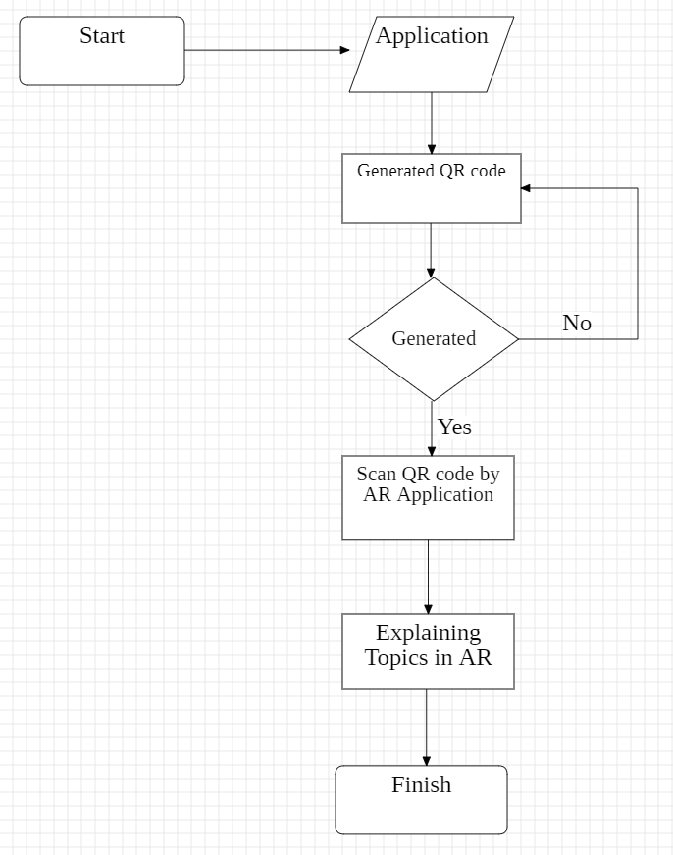

**Figure: Architecture diagram of the proposed system**

**CONCLUSION AND FUTURE SCOPE**

The modules are completed as a platform for developing each word explanations in this system using augmented reality and also the android application with an interactive user interface. Students can use this application for understanding concepts and students get more interesting and interactive concepts here. The contribution of AR in providing the demonstration of Image, video, 3D model explanations with audio clip it helps in making the understandability much easier to student and interactive. Henceforth, this implementation leads to a new opportunity to understand complex words into a convenient platform and reduce the difficulty in learning about the books and also provides a better learning experience. Further enhancement of the application would be implementing the other chapter explanations with 3D modules. And further, it can be developed for other subjects also like mathematics, social science and EVS. An application can be further enhanced to the cross-sectional view of different subjects. which will be very useful to students. Also, further, it can be developed for complete chapter explanation it will help the student to learn interactive and interesting mode.

**REFERENCES**

[1] B. Siregar, F. Syahputra, U. Andayani, Abdul Gani, M. F. Syahputra, M. B. Siregar, Abdul Gani “Augmented for Respiratory system using Leap Motion Controller”, International Conference of Science, Technology, Engineering, Environmental and Ramification Researches, 2018, pp.1900-1904.

[2] Francesca Beatrice, Juan Cano, Caramen Juan, “An Augmented Reality System for Learning the Interior of the science”, 8th IEEE International Conference on Advanced Learning Technologies, 2008, pp.186-188.

[3] Chien-Huan Chien, Tay-Sheng Jeng, “An Interactive Augmented Reality System for Learning Anatomy Structure”, Proceedings of Multiconference of Engineers and Computer science, 2010, pp.978-988.

[4] Andreas Rienow, Carsten Jürgens Claudia Lindner, Augmented Reality applications as digital experiments for education – An example in the Earth-Moon System, 2019, DOI:

[5] Gunawan Witjaksosno, Michael H., Kurniawan, Suharjito, Diana “Science Learning Systems Using Augmented Reality on Mobile Application”, 3rd International Conference on Computer Science and Computational Intelligence: Empowering Smart Technology in Digital Era of Better Life”, 2018, pp.80-88.

[6] Muhammed kofoglu, c Dargut, Reyhane Arslan, “Development of Augmented Reality Application for Biology Education” in Journal of Turkish Education, volume 7, Issue 1, March 2020